1.Have the function ArrayChallenge(arr) read the array of integers stored in arr which will be in the following format:[k,r1,r2,r3...] where k represents the number of desks in a classroom, and the rest of the integers in the array will be in sorted order and will represent the desks that are already occupied.All of the desks will be arranged in 2 columns where desk#1 is at the top left,desk #2 is at the top right,desk #3 is below #1,desk #4 is below #2, etc. Your program should return the number of ways 2 students can be seated next to each other.This means 1 student is on the left and 1 student on the right,or 1 student is directly above or below the other student.

for example:if arr is[12,2,6,7,11]then this classrooms looks like the following picture:

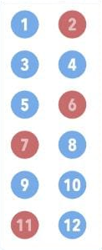

Based on above arrangement of occupied desks,there are a total of 6 ways to seat 2 new students next to each other.The combinations are:[1,3],[3,4],[3,5],[8,10],[9,10],[10,12].So for this input your program should return 6.K will range from 2 to 24 and will always be an even number.After k ,the number of occupied deska in the array can range from 0 to K.